THE BOARD OF TRUSTEES OF THE WESTCHESTER OWNERS COMMITTEE HELD THEIR REGULAR BOARD OF TRUSTEES MEETING ON TUESDAY, NOVEMBER 15, 2022, AT 625 NOTTINGHAM OAKS TRAILS, ROOM C-11, HOUSTON, TX 77079. MEETING NOTICE ATTACHED AS EXHIBIT "A".
*******************************************************************************************
TRUSTEES PRESENT: Michael Williams, Russell Pae, Natalie Hightower, Erin Fulweber, Joe Strong and Ryan Renfro. Andrea Stevens, Kristie Tobin and Dave Anderson were not in attendance. Also present: Heather Esteban of Crest Management Company.

CALL TO ORDER:

The meeting was called to order at 6:00 P.M. The agenda was adopted as presented.

HOMEOWNER FORUM
An owner in attendance stated he was disappointed that the Board did not follow procedures for approval of the roof replacement at the pool building. The Board advised him that they in fact did follow procedures, the roof replacement expense was approved by the Board in between Board meetings and then ratified during the October 18, 2022 Board meeting.

FINANCIAL REPORT
The October 31, 2022, financials were presented to the Board. As of October 31, 2022, there was a total cash balance of $124,007.86 in the Operating Account and the Non-Capital Reserve Account had a balance of $93,192.96. Assessment receivables totaled $5,106.22.

COMMUNITY RELATIONS: Trustee Williams advised that after the conversation during the October Board meeting about the responsibilities of the Secretary as well as the Community Relations Chair he researched the position descriptions in the By-laws and sent out an email to the Board and the complaining owner. Email is attached to the minutes.

POOL & TENNIS: The Mom’s Club is holding events at the club.

MAINTENANCE: Trustee Strong advised the permit and inspection process have been completed for the pool building roof. The final project for the year will be resurfacing the ‘cool’ deck flooring at the pavilion.

TRASH & PEST CONTROL: No report as Dave Anderson was not in attendance.

PATROL: Trustee Fulweber read through the report of the recent calls for service in the community.

RAP NEWSLETTER: Nothing to report.

NEW BUSINESS:
Ratifications of Decisions Made Between Board Meetings – The Board ratified the following decisions made between Board meetings:
- October 23, 2022 the Board approved the minutes of the meeting held October 18, 2022.
- October 23, 2022 the Board approved the estimate from Travelers for the one year D&O Insurance policy to begin November 23, 2022 at a cost of $5,486.00.
- November 4, 2022 the Board approved an estimate from Hancock Pools to resurface the ‘cool’ deck flooring at the pavilion and repaint the ‘cool’ deck flooring on the porches of the clubhouse for a total cost of $12,000.00.
- November 9, 2022 the Board approved a $300 donation to the Mom’s Club for a community event.

EXECUTIVE SESSION SUMMARY
- The Board reviewed the collection status report dated November 9, 2022.
- The Board reviewed the inspection report dated November 15, 2022.

NEXT MEETING
The next meeting will be held Tuesday, December 13, 2022, at 6:00 p.m.

ADJOURNMENT
There being no further business, and upon a motion duly made and seconded, the meeting was adjourned at 6:47 p.m.

APPROVED:

Date Russell E. Pae – Secretary

ATTACHMENT:

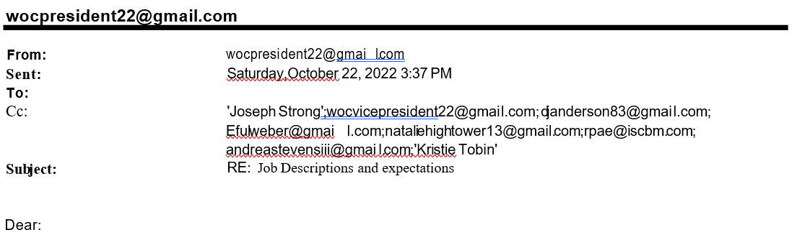
I am sorry to have to reiterate to you that you are sorely misinformed about the Board Positions you are citing, and about which you seem vehemently angry. The Secretary and Community Relations positions and descriptions are included below. This Board has been fully covering these and all our responsibilities.

You are attacking one person on the Board for not properly handling their position, and for not properly contributing to our WOC. I feel I can safely speak for all our Board members that you are completely wrong on this matter, that all our Board members have been fulfilling their job responsibilities, and more. I also put forth that you are not a member of the Board and therefore have no insight into any of our Board members unique contributions. I request that you go no further with your verbal and written attacks.

Regarding the National Night Out, having checked the list of neighbors willing to host I notice you did not volunteer to do so on your street. I’m certain that you had a great reason for not putting your name forth to host. However, this is a volunteer offering, nationally promoted for many years, so the date should not have come as a surprise to anyone who wanted to participate. The Board does not disagree that this is an opportunity lost for neighbors to gather and get to know each other, but it cannot be mandated.

Nowhere in the By-laws or CCR’s does it say the Community Relations position has anything to do with seeking out, planning, hosting, or organizing events such as National Neighborhood Night Out. Again, see below.

I write this not only to address your most recent attack, but also to let you know that I will need to reiterate these statements at the next Board meeting, to ensure that your comments do not cause any further misunderstanding of what the Board’s responsibilities are to our WOC community.

By-Laws as of 2002, up to date:
SECTION 13. Community Relations Chairman. The Community Relations Chairman shall be responsible for representing the Corporation before various public offices that provide services to the community and for providing liaison as required between the Board and the Westchester Women's Club and other organizations

By-laws from 1990
SECTION 13. Community Relations Chairman. The Community Relations Chairman shall be responsible for representing the Westchester Owners Committee before the Memorial-Dairy Ashford Civic Association and before various public offices providing services to the community other than those enumerated above and for providing liaison as required between the Board and the Westchester Women's Club and the Westchester Club.

Notes on Section 13:
It is evident that the Community Relations position (“..representing the Corporation in front of public offices..”) was meant to follow the local, city, state and issues that may affect our neighborhood. Such as: Drainage, Water and Sewage issues, Army Corps of Engineers, Memorial Super Neighborhood, the change of our District G boundaries, the building of multi living buildings… Back in history the local on that was the Memorial-Dairy Ashford Civic Association. Its replacement is now the Memorial Super Neighborhood, whose meeting I have been attending and reporting back on issues such as HPD’s reports on crime and the multi-living buildings going up on Memorial Drive.

Further in the description “liaison between… Westchester Women’s Club and other organizations.” The Westchester Womens’ Club eventually became the Westchester-NF8 Womens’ Club. And there was even a Mothers’ Day Out group that had a couple of stay-at-home Dads as members. Unfortunately, neither of these groups are active. Although a new “Mom’s Club” seems to be forming and there is talk of revitalizing the Westchester Womens’ Club.

Nowhere in the previous or up to date versions or any place else in the By-laws or CCR’s does it say this position has anything to do with seeking out, planning, hosting, or organizing events such as National Neighborhood Night Out.

By-laws of 2002 and 1990 are the same
SECTION 7. Secretary. The Secretary shall: (a) keep the minutes of the meetings of the members and of the Board of Trustees in one or more books provided for such purpose; (b) see that all notices are duly given in accordance with the provisions of these by-laws or as required by law; (c) be custodian of the corporate records of the corporation; (d) keep a membership roll of the members of the corporation; (e) sign with the President or Vice President any instruments as authorized by resolution of the Board of Trustees; (f) distribute to each Trustee at least one week prior to the next scheduled Board meeting a copy of the draft minutes of the previous meeting, together with such other written material as may have been submitted beforehand to the Secretary for consideration at the next Board meeting; and (g) in general perform all duties incident to the office of Secretary and such other duties as from time to time may be assigned to him by the President or by the Board of Trustees.

Notes on Section 7:
Even though for the past six plus years a number of these duties have been handled by the Management Companies, all have been accomplished.

Regards,
Michael
--
Michael Williams
Westchester Owners Committee- President 2022
M: 832-452-7590
E: wocpresident22@gmail.com

